Stack->

-1.is a child of a vector class.

2.lifo.(last in first out).

Stack s=new Stack();

Methods of Stack->

1.push(object O);//to insertion

2.pop();//to deletion

3.peek()//top of a stack

4.empty()//to check wehter the stack is empty or not

5.search(“a”);//offset from top of the stack number.then this method return offset value.

And if search element not found then we easily return(-1)

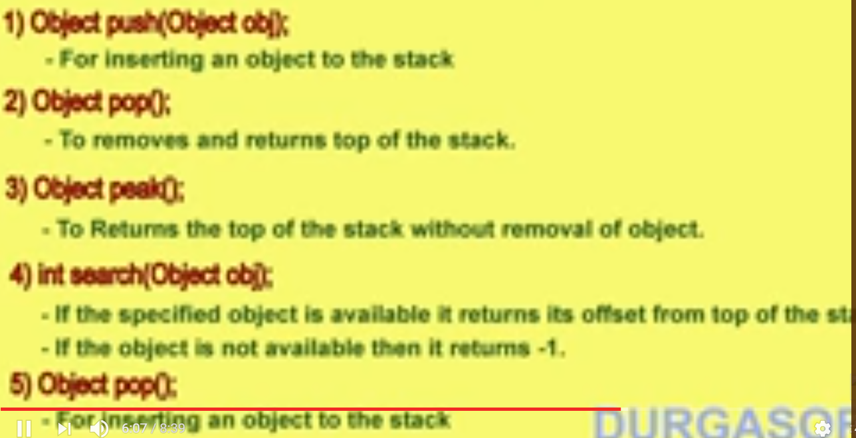

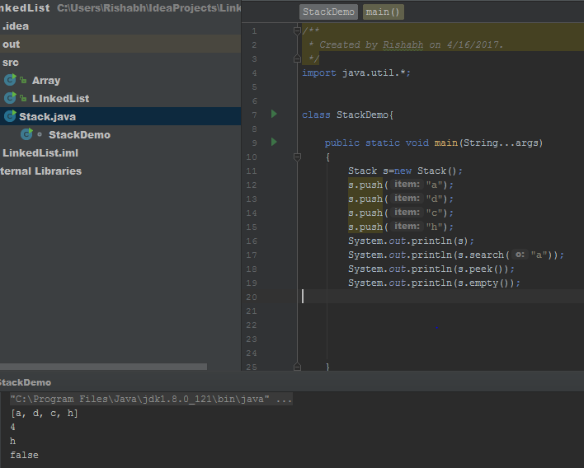

NOW IF YOU WANT WE IN EFFICIENT FOR MANIPULATION THEN USE STACK __>

PROBLEM_>

